**Responsive Supramolecular Materials Based on Amphiphilic Principles for Controlled Release, Light-Harvesting, Transport, and Catalysis**

**Yan Zhao, Department of Chemistry, Iowa State University, Ames, IA 50011**

Biomolecules routinely carry out binding, transport, and catalysis not only with great efficiency but also in response to chemical and physical stimuli in a highly precise manner. Two of the most important principles underlying these remarkable molecular processes are conformational control and amphiphilic manipulation.

We have prepared foldamers from facially amphiphilic cholate building blocks. The oligocholates can fold into helical structures with nanometer-sized internal hydrophilic cavities (Scheme 1). Cavities of this size are typically observed only in the tertiary and quaternary structures of proteins but are formed in the oligocholates prepared in just a few steps from the monomer. Similar to many proteins, the oligocholate foldamers display cooperativity in the folding/unfolding equilibrium and follow a two-state conformational transition. The foldamers can be easily modified by the incorporation of natural amino acids and the folding has a remarkable tolerance for structural perturbation. Their conformational change could be triggered by solvent polarity, pH, or the presence of metal ions or organic molecules. The tunable conformational change has enabled the applications of these foldamers in biomimetic binding, sensing, molecular transport across lipid membranes, and catalysis.

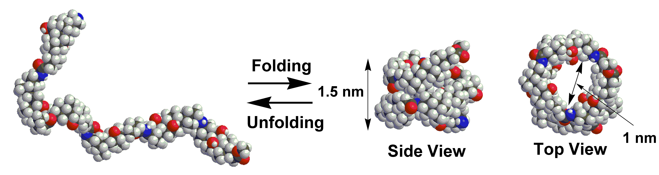

Scheme 1. The folding and unfolding of an oligocholate.

 Micelles are dynamic assemblies of surfactants in water, driven by a balance between the hydrophobic interactions among the tails and the electrostatic/steric repulsion among the headgroups of the surfactants. Crosslinking of an alkynylated cationic surfactant yielded surface-crosslinked micelles (SCMs) as easy-to-functionalize, multivalent water-soluble nanoparticles. These nanoparticles could encapsulate hydrophobic guests and undergo controlled release extremely rapidly with prescribed chemical signals. They also serve as platforms for novel light-harvesting systems and protein-like receptors with extraordinary molecular-recognition properties.