**学 术 报 告**

**Designer Nano-materials for Delivery Applications**

**Presenter: Prof Chengzhong Yu**

Australian Institute for Bioengineering and Nanotechnology

The University of Queensland

Contact: c.yu@uq.edu.au

**Abstract:**

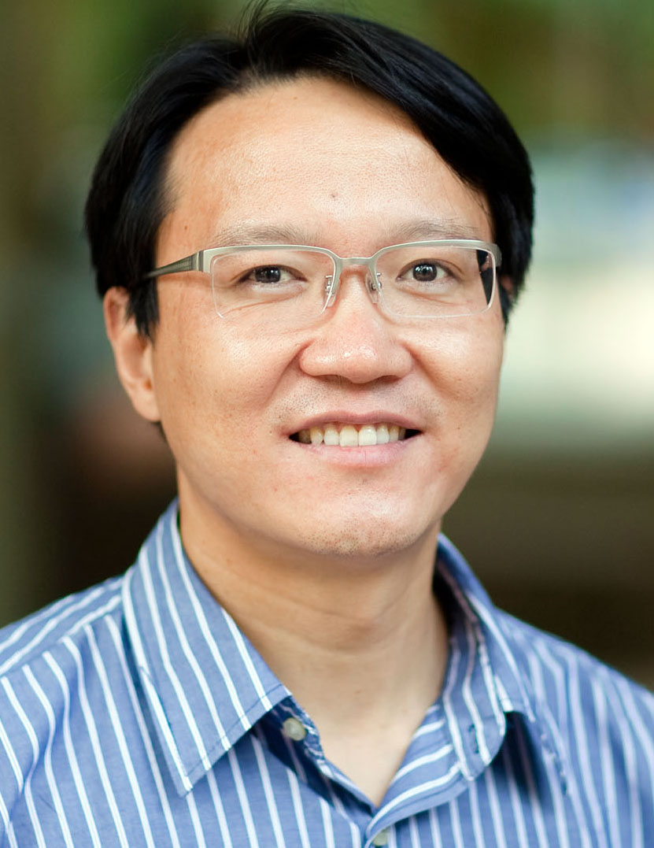

Prof. Yu is a chemist and materials scientist in functional nanostructured composites and their applications. Since 2000, he has published over 180 peer-reviewed journal articles, which have been cited over 9000 times and resulted in an H-index of 50. Since he joined The University of Queensland in 2010, he has attracted 5 DP, 2 LIFF, 1 Future Fellowship and 1 Linkage from the Australian Research Council, 1 grant from the Cancer Council of Queensland, 1 Queensland Research Partnership Project. He has developed broad industrial collaborations to extend the applications of functional materials in a real world. He has received several awards including the Le Févre Memorial Prize, the IUPAC Distinguished Award for Novel Materials and their Synthesis, and the Second prize of the National Science Award of China (Ranked 3/5).

In this talk he will summarise the latest progresses in his group on the designed synthesis of functional nano-materials and their applications, with a focus on drug delivery for improved healthcare.

**报告时间**： **2015年4月27日（星期一）下午4:00**

**报告地点**： **天南联合大厦A座2楼会议室**

**南开大学 化学学院 先进能源材料化学教育部重点实验室**