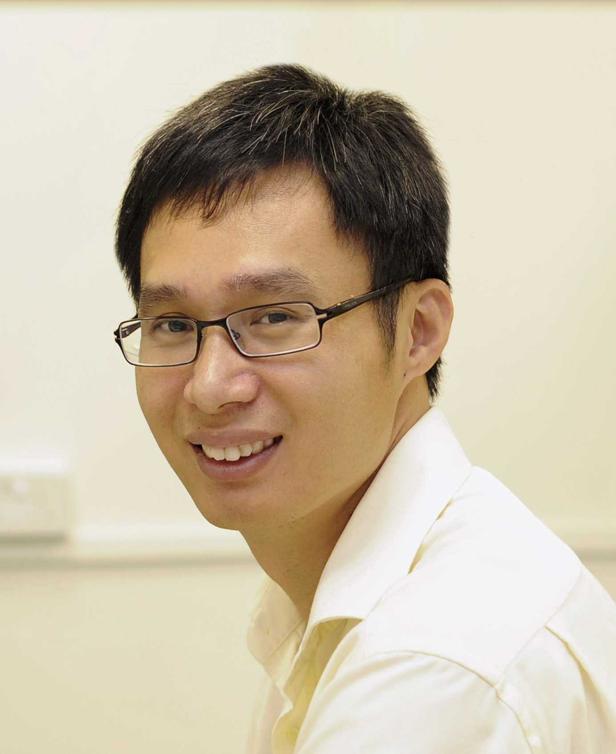

先进能源材料化学教育部重点实验室学术讲座
报告题目：Rational Materials Design for Ultrafast Rechargeable Lithium-ion Batteries

报告人：Dr. Xiaodong Chen
Nanyang Technological University (Singapore)
时间：2014年12月26日上午10:00
地点：联合楼A座二楼会议室
欢迎师生参加！

CV of Dr Xiaodong Chen

Dr. Xiaodong Chen is an Associate Professor at the School of Materials Science and Engineering, Nanyang Technological University (Singapore). He received his B.S. degree (Honors) in chemistry from Fuzhou University (China) in 1999, M.S. degree (Honors) in physical chemistry from the Chinese Academy of Sciences in 2002, and Ph.D. degree (Summa Cum Laude) in biochemistry from University of Muenster (Germany) in 2006. After his postdoctoral fellow working at Northwestern University (USA), he started his independent research career as Nanyang Assistant Professor at Nanyang Technological University since 2009. Since Sept 2013, he was promoted to Associate Professor with tenure. His research interests include integrated nano-bio interface and programmable materials for energy conversion. So far, He has published over 130 scientific articles, including in Nature Nanotech, Nature Chemistry, Nature Communications, JACS, Angew Chem, and Adv Mater, and has given more than 100 invited talks/seminars. Since November 2013, he is the associate editor of Nanoscale. In addition, he is the editorial advisory board member of Advanced Materials, Scientific Reports, and Journal of Laboratory Automation. He has been awarded more than ten prestigious awards and fellowships including the precious Singapore NRF Fellowship, the Tan Chin Tuan Exchange Fellowship, and the best PhD Dissertation award at the University of Muenster.

